SMOKE MAZE TRAILER 2493KW
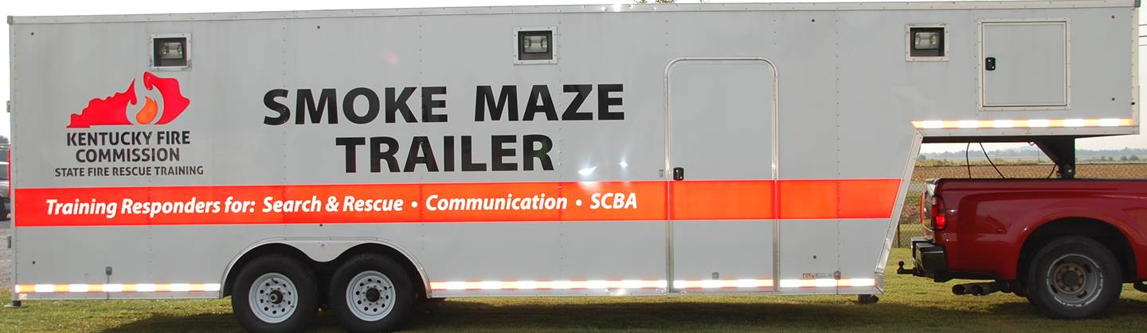

LOCATION:

District 3 Training Center
Calhoun, KY

SPECIFICATIONS:

Length 33’
Width 8 ½’
Mfg Date 2013
Gooseneck Hitch

OBJECTIVES:

The Smoke Maze Trailer is designed for the following objectives:
-1) improve communication in a vision restricted & noisy environment
-2) monitor and coach responder breathing patterns in a challenging environment
-3) practice search and rescue in a controlled, vision restricted environment
-4) promote and practice self-rescue & assisted rescue skills in a vision restricted environment

CAPABILITIES:

The Smoke Maze Trailer has two levels. Each floor has approximately 3 ½’ ceiling clearance. There are chain-link fence panels configured within the trailer on each level to create a maze throughout the trailer. The trailer has plumbing to evenly disperse training smoke to reduce the visibility throughout the trailer. There is flashing red lights in areas to provide the sensation of being on a fire scene. There is a siren generator and speaker that provide loud noises to add to the disorientation of the responder.
In the front of the trailer, there is a set of ‘rafters’ to simulate crawling through the attic space of a house. There is a door and door knob for the firefighter to find. There is a ramp simulating a ceiling collapse. This allows the instructor to walk the responder through the appropriate procedures to follow to maneuver this type of incident.
This trailer requires a 110 volt power source to operate.

