ROPE RESCUE TRAINING 2960KW

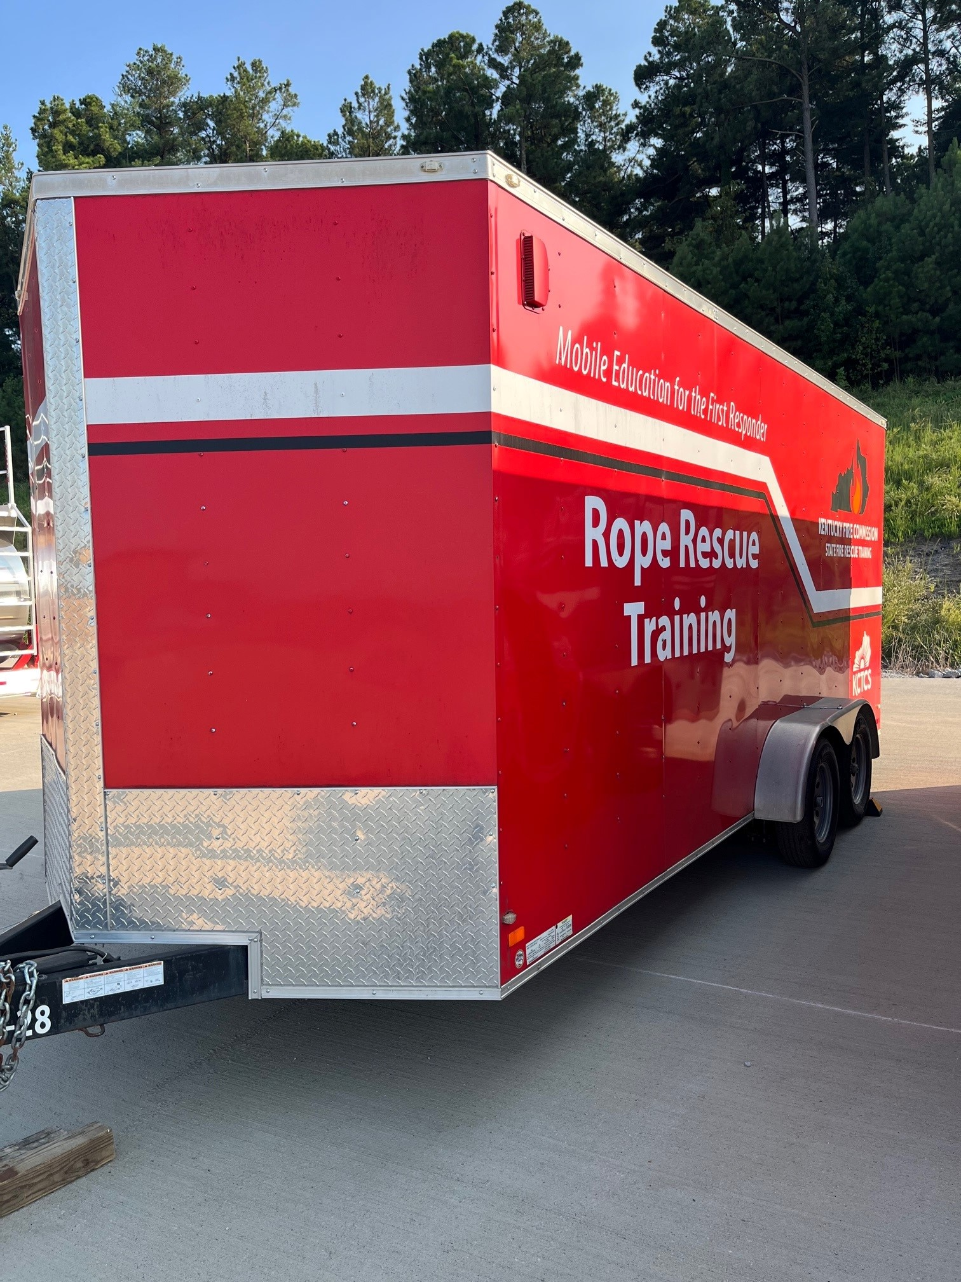

LOCATION

District 3 Training Center
Calhoun, KY

SPECIFICATIONS:

Length 18’
Width 8’
Mfg Date 2016
Tag-along 2 5/16” ball

OBJECTIVES

To carry the equipment necessary for Rope Rescue Training classes from the Awareness, Operations to the Technician level Rope Rescue courses.

CAPABILITIES

This trailer contains ropes, equipment, harnesses and other equipment necessary to support a rope rescue class.

