CONFINED SPACE RESCUE TRAILER 3276KW

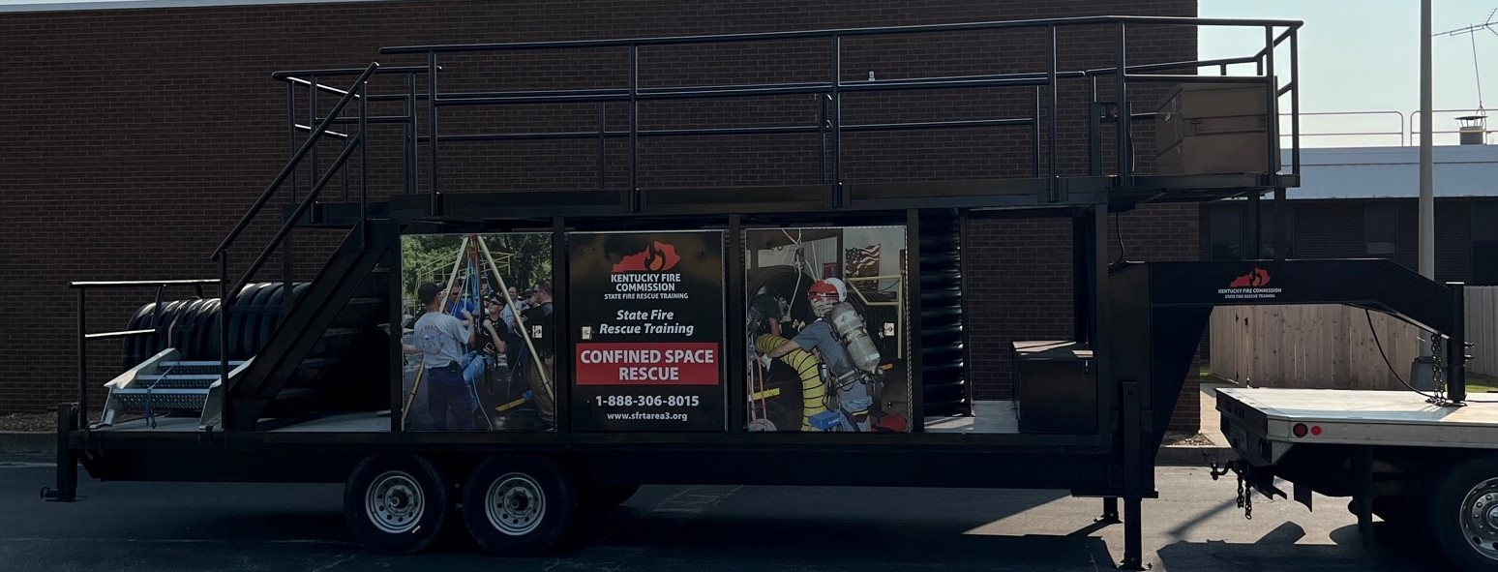

LOCATION:

District 3 Training Center
Calhoun, KY

SPECIFICATIONS:

Length 33’
Width 8 ½’
Mfg Date 2020
Gooseneck Hitch

OBJECTIVES:

The Confined Space Rescue Trailer is designed for the following objectives:
-1) train the fire service in the ways to rescue victims from confined spaces
-2) train industrial workers how to rescue victims from confined spaces
-3) to provide compliance to the standard 29 CFR 1910.146 pertaining to annual performance of rescue from confined spaces

CAPABILITIES:

The Confined Space Rescue Trailer is designed with two vertical openings on the top (one 36” and one 30”). Each opening has a steel door that allows for safety when working in the other hole. There is a three foot hand rail that surrounds the top deck for safety.
There is a horizontal opening on the side of the trailer. Additionally there is a vertical opening underneath the trailer to practice travelling up into a confined space.
This trailer is fully equipped with ropes, rescue equipment, safety equipment, harnesses and a tripod system. Additionally, the trailer is equipped with an electronic winch to aid in the loading and unloading of the tubes carried on top of the trailer to create a “complex” rescue scenario for the rescuers training with this prop.

