HONOR GUARD TRAILER 2857KW

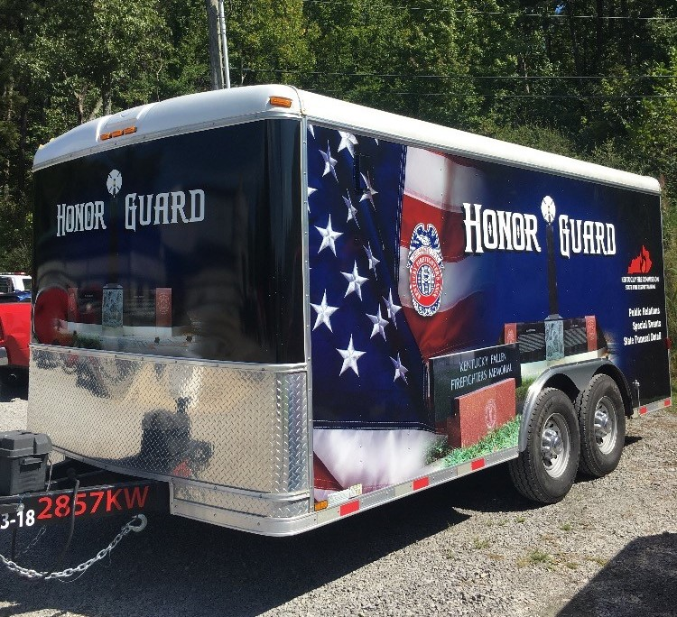

LOCATION

District 3 Training Center
Calhoun, KY

SPECIFICATIONS:

Length 16’
Width 8’
Mfg Date 2015
Tag-along 2 5/16” ball

OBJECTIVES

To support Funerals and special events across the Commonwealth when a member of the fire service family dies.

CAPABILITIES

This trailer contains honor guard uniforms, flags, and other items necessary for conducting a funeral with honors for members of the fire service.

