**HAZMAT OPERATIONS TRAILER 3093KW**

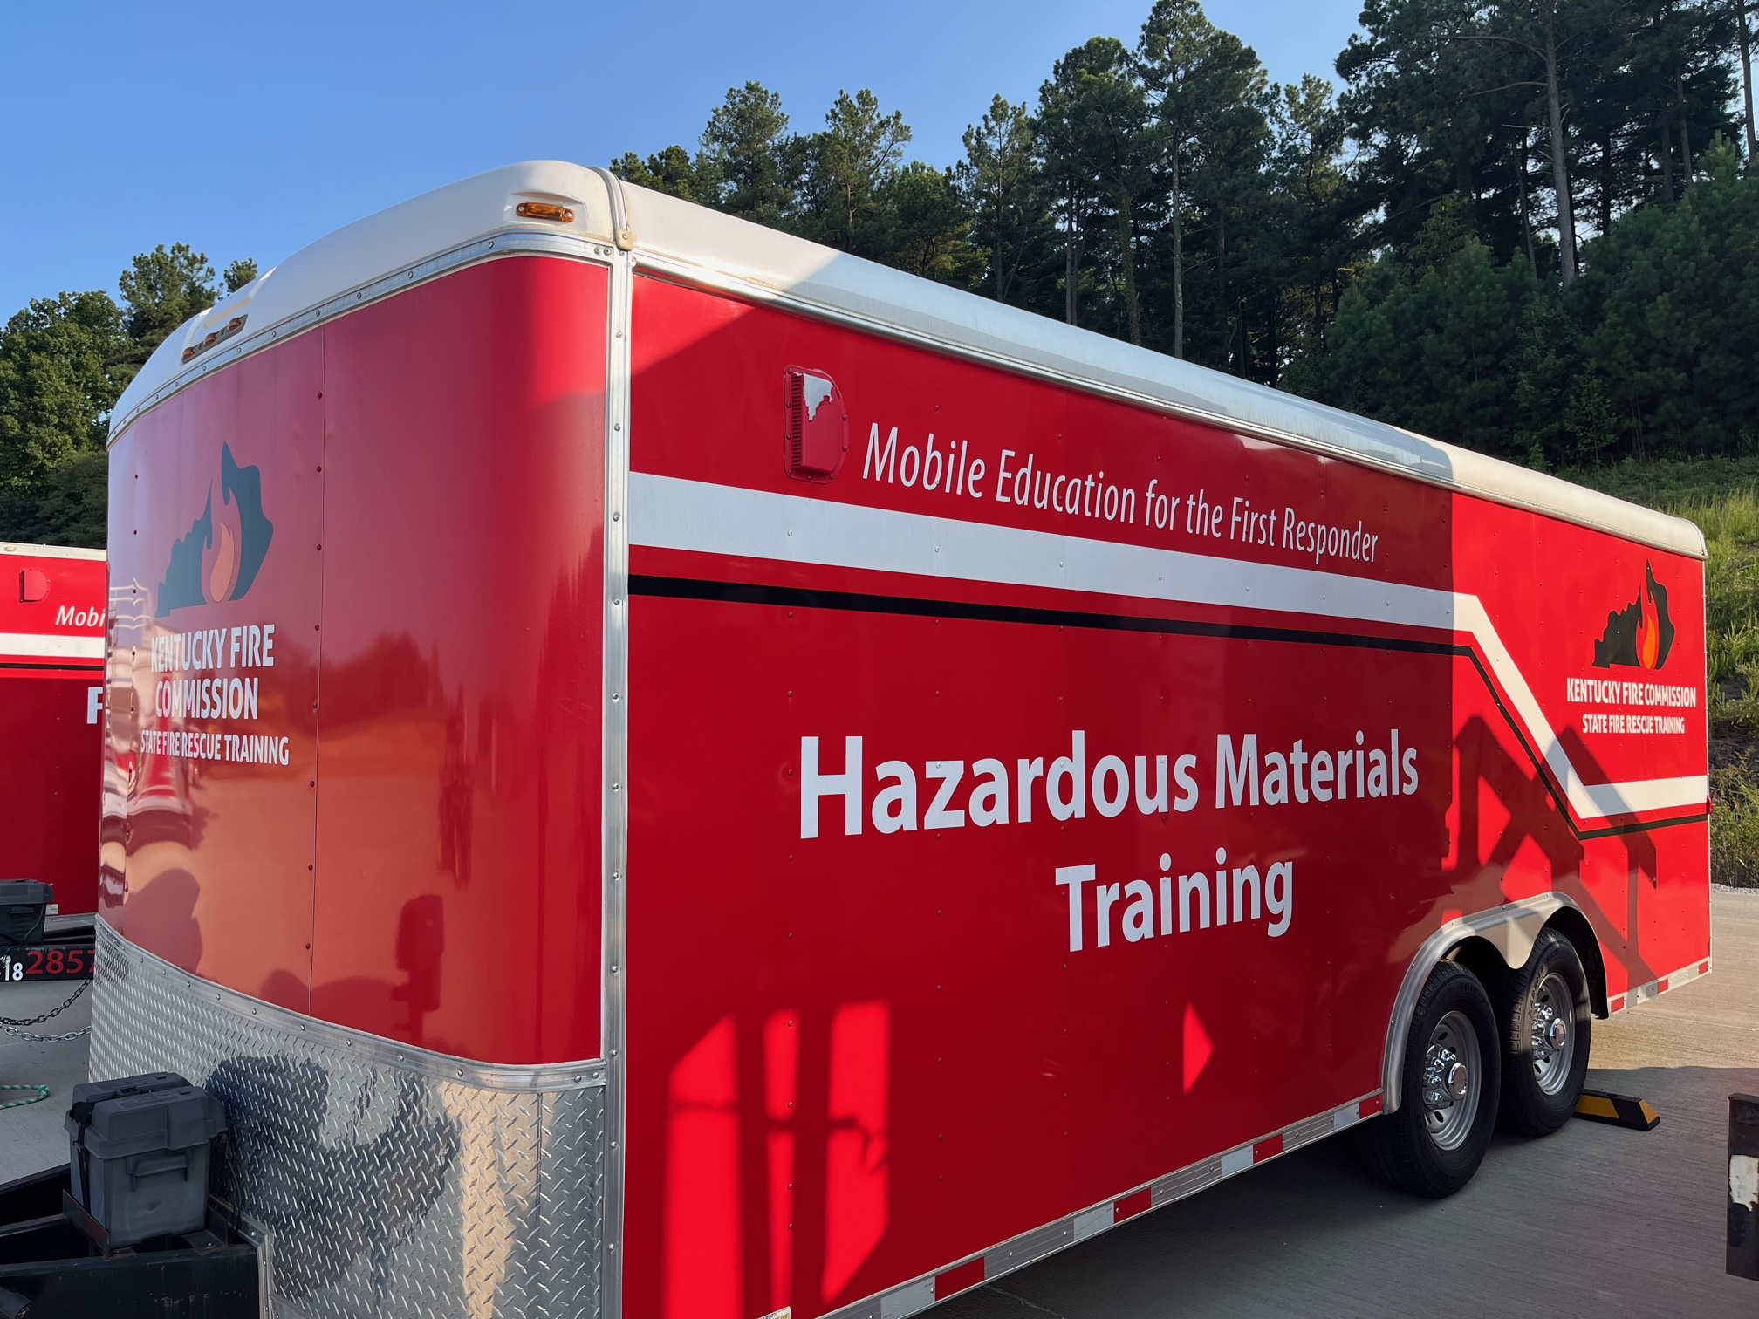

**LOCATION**

District 3 Training Center

Calhoun, KY

**SPECIFICATIONS:**

Length 20’

Width 8’

Mfg date 2019

Tag-along 2 5/16” hitch

**OBJECTIVES**

To provide the tools and supplies to provide a hazardous materials operations or refresher training class to hazmat responders.

**CAPABILITIES**

This trailer carries reference materials, hazmat suits of all levels, plug and patch kits, and over pack barrels. This trailer carries the materials to support a hazmat operations level or refresher training class.