FORCIBLE ENTRY/VENTILATION TRAILER 2875KW

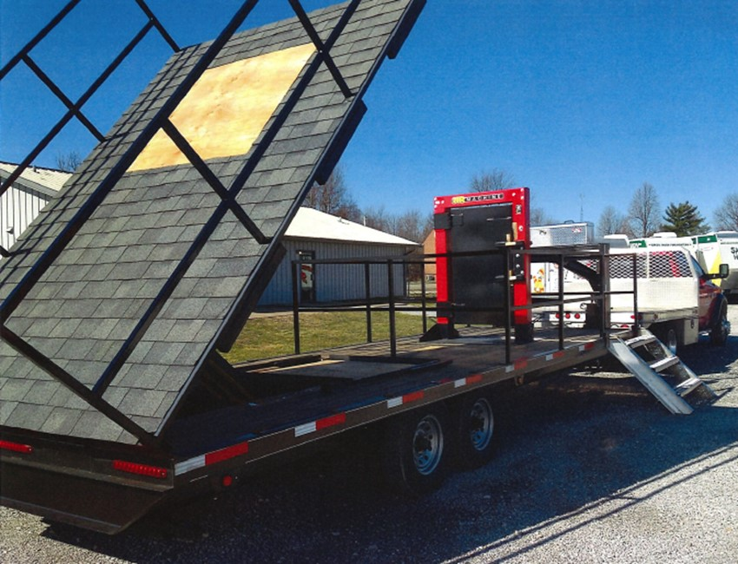

LOCATION

District 3 Training Center
Calhoun. KY

SPECIFICATIONS:

Length 25’
Width 8’ 6”
Mfg date 2015
Gooseneck hitch

OBJECTIVES

This prop has a dual mission of training firefighters the procedures for ventilating a pitched roof and forcing entry through an inward and outward swing door.

CAPABILITIES

This trailer has a ‘Shingled Roof’ on the rear. The roof can be set at a 12/12, 8/12 or a 4/12 pitch to allow the firefighter to work on various pitches within their district. The roof has an insert for a piece of plywood for the purpose of chopping or cutting, thus simulating a ventilation scenario.
The front half of the trailer has a forcible entry door that can simulate an inward swinging door or an outward swing door allowing for practice of entry through either. The trailer is equipped with guard rails allowing for an added level of safety while practicing these skills.

