FLATBED TRAILER 1977KW
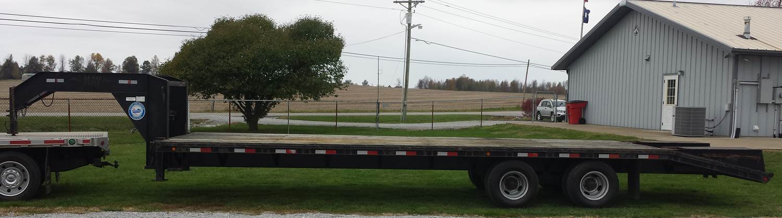

LOCATION

District 3 Training Center
Calhoun, KY

SPECIFICATIONS:

Length 39’ (30’ deck length)
Width 8’
Height 38” (deck height)
Weight 20,000 lb capacity
Mfg Date 2006
Gooseneck Hitch

OBJECTIVES

To carry heavy loads

CAPABILITIES

This trailer has a 30’ flat bed with the ramps folded up. It has dual wheels and two axles, each rated for 10,000 pounds making the payload up to 20,000 pounds. The trailer has an 8,000 lb winch mounted in a receiver in the front of the trailer to aid in loading a dead weight. There are chains and straps in a tool box in the front of the trailer.

